Activity: Interaction types, interaction modalities, affordances, signifiers, and the gulfs
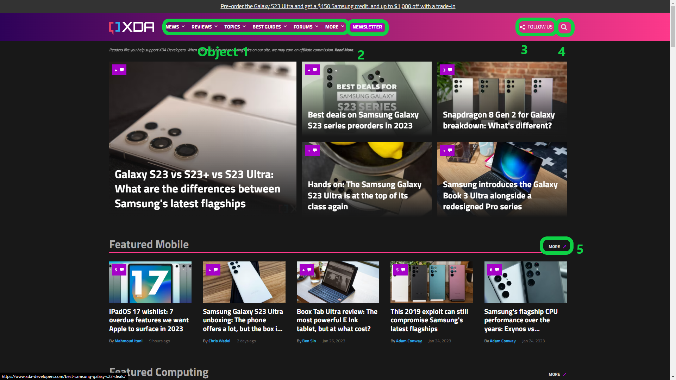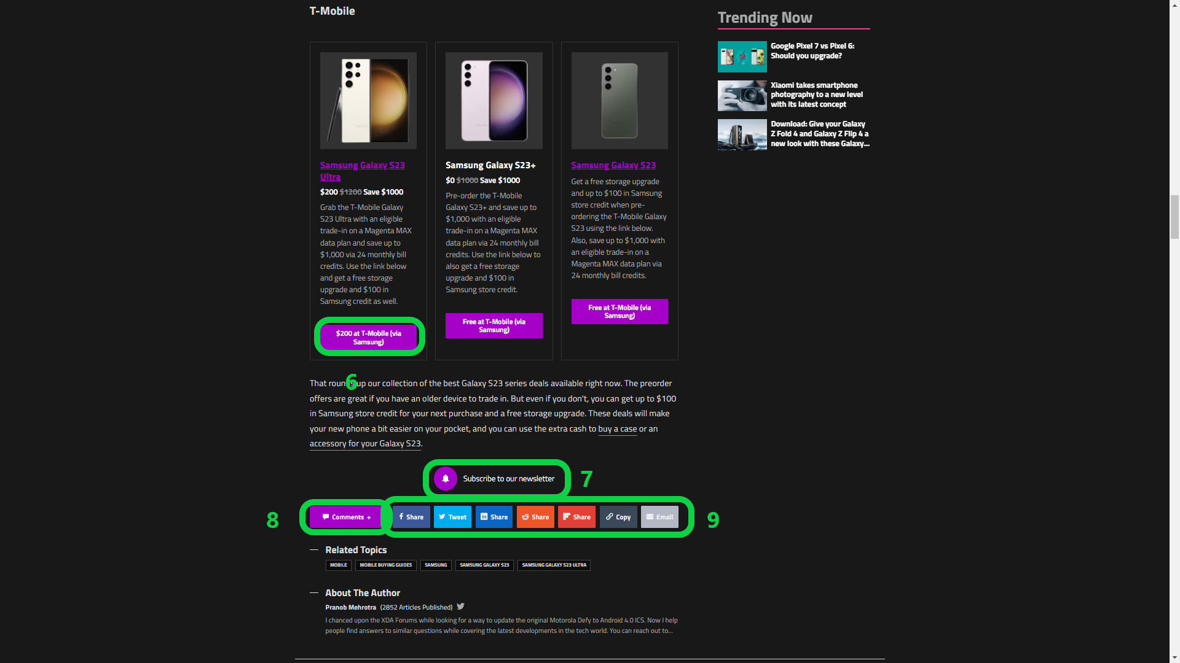
Part 1: Interaction Types and Modalities

- What are the interaction types that are used in the web site? Where do they occur?
  - Type: Instructing
  - Occurs: links, buttons, navigation bar
- What is the main interaction modality that is used in the web site? Are there other modalities that work for part of your website (i.e. speech input)? Or other modalities the user may choose to use (i.e. touch on mobile)? Are there any challenges that may arise when using the website with these other modalities?
  - GUI, Mobile, Touch
- Critique and make recommendations for the current and potential interaction types and modalities used in the web site. This part is an important part of your critique - can you imagine how this web site could include more modalities than a typical web site? Based on the interaction types that are most common on your website, what is another modality that could support those interactions?

Part 2-a: Affordances and Signifiers
Object | Affordance | Signifier
1 | the ability to opens sub navigation menu under word text | signified by ”⌄” symbol right of each text
2 | Navigate to subscribe to xda-developers newspage | signified by word “Newsletter”
3 | Follow on social media buttons | signified by share icon & word “FOLLOW US”
4 | Search bar for site | signified by Search Icon “🔍”
5 | Opens mobile topic page | signified by “↗” icon & word “MORE”
6 | Opens to external page samsung store device page for Samsung Galaxy S23 Ultra | signified by rectangle button & word in inside button “ $200 at T-Mobile (via Samsung)”
7 | Same OBJECT 2 | signified by bell icon & word “Subscribe to our newsletter”
8 | Open comments widget for current page | signified by chat icon & word “Comments”
9 | Same OBJECT 3 | signified by different color & icons button

Part 2-b: Gulf of Execution and Evaluation

 | Task 1 - Navigation Bar | Task 2 - Search | Task 3 - Articles
Gulf of Execution: How does the user know what to do? | User knows what to do cause the dropdown ⌄ symbol besides text. | Search Icon on the right of the navigation bar. | When you hover over the image or Article title text, underlines appear on title text, and cursor changes to click cursor icon implying you can click and open the page.
Gulf of Evaluation: How does the user know what happened after initiating a task? After the user has performed an action, how does the user know what state the system is in? | When the cursor hovers over text, the sub menu automatically opens, and by clicking on text in sub-menu, you will navigate to the page the text is linked to. | After clicking the icon the search bar opens with words saying “Search XDA Developers”. | After clicking you will be navigated to the article page.

Part 2-c: Critique and Recommendations for Improvement
- Affordances & signifiers were used minimally and efficiently.

